Cost-effectiveness of empathic healthcare



A protocol by Kleijnen Systematic Reviews Ltd and University Medical Center Groningen
for the Stoneygate Centre for Empathic Healthcare
June 2025

Kleijnen Systematic Reviews Ltd
Unit 6, Escrick Business Park
Riccall Road
Escrick
York
YO19 6FD
United Kingdom
Telephone: +44 (0)1904 727980
Fax: +44 (0)1904 720429
Email: nigel@systematic-reviews.com
Website: www.systematic-reviews.com
TABLE OF CONTENTS
1. Background 5
2. Objectives of the project 6
3. Research questions 7
4. Methods 7
4.1 Population, Intervention, Comparator, outcomes, time horizon (PICOT) 7
4.2 Model structure 9
4.3 Sources of data for parameterisation – Targeted Literature Reviews 10
4.4 Sensitivity analysis 14
4.5 Subgroup analysis 14
4.6 Scenario analysis 14
4.7 Model validation 15
4.8 Results 15
5. Deliverables 15
5.1 Economic model 16
5.2 Journal manuscripts 16
6. References 17

Background
﻿Empathy in the healthcare setting is defined as listening, understanding someone’s situation and feelings, caring, and helping, all while respecting personal boundaries (1). Empathy-based interventions have been associated with improved patient outcomes, including improving in pain, anxiety, disease-related outcomes, and patient satisfaction (2–4). Beyond patient outcomes, such interventions may also benefit physicians by reducing burnout and enhancing professional fulfilment as found in published systematic reviews (5,6). However, available randomized trials offer limited evidence regarding disease-specific outcomes, long-term effects, impacts on quality of life and associated costs. Consequently, there is limited economic evidence assessing the value of empathy-focused interventions. To the best of our knowledge, no modelling study has yet been conducted to estimate their potential values of such intervention.
A novel empathy training program has recently been developed and piloted in an experimental study involving healthcare professionals in a maternity unit (7). While the intervention was tested in a secondary care setting, its design and theoretical foundation suggest potential applicability in other contexts. To inform the continued development and optimization of such interventions, a flexible, early-stage economic evaluation is warranted. Rather than focusing on a single disease or care context, a generalizable economic model allows users to explore the impacts of the intervention to various populations and delivery formats, helping developers identify the most promising settings for future implementation and trial investment. As the ultimate goal of empathy training is to improve patient care, the intervention under investigation in this study is defined as a combination of empathy training for healthcare professionals or nonmedical laypeople (referred as providers in this protocol), followed by the delivery of empathic care to patients, called empathy-enhanced intervention for short.
While cost-utility analysis (CUA) is the standard approach in health economic evaluation, its applicability to empathy-based interventions is limited due to distinct features of such interventions. Given the behavioral focus and multi-component structure including a training program and delivering empathic care, empathy-based intervention shares more key features with health technologies than with traditional pharmaceutical interventions (8). These features include dependence on user competence, evolving intervention formats, limited evidence base, and dynamic pricing and delivery, ultimately complicating standard economic evaluation approaches (8). Moreover, empathy interventions may generate benefits across several domains, for instance, pain, anxiety, patient satisfaction, and provider wellbeing. Each of these is valuable but difficult to aggregate into a single outcome metric such as the quality-adjusted life year.
In this context, a cost-consequence analysis (CCA) is a recommended method for the economic evaluation of medical technologies (8). Moreover, CCA is particularly relevant when an intervention is being piloted, when multiple health and non-health outcomes cannot be easily summarized in a single metric, or when decision-makers are focused on broader patient-centered outcomes such as satisfaction and psychological wellbeing (9). CCA presents both costs and outcomes in disaggregated form, allowing decision-makers to weigh trade-offs transparently. This approach is particularly suited to early-stage, multi-outcome interventions like empathy training, where the value lies in a constellation of modest improvements rather than a dominant health gain in a single domain. Accordingly, we will adopt the CCA method using a modelling approach following NICE guidance (10) using a multi-use model to evaluate the cost and consequences of implementing the given empathy intervention across diverse clinical contexts.
Given the scope and timeframe of this study, the model will be applied to two distinct settings: primary care and secondary care. Firstly, general practitioners (GPs) and patients consulting them were chosen as the populations in the primary care setting. This choice reflects the central role GPs play in delivering first-contact, longitudinal, and holistic care (both physically and psychologically) within the UK health system. Secondly, nurses and women diagnosed with recurrent miscarriage under care at maternity units or gynecology clinics were selected for the secondary care case study. This patient population is particularly vulnerable to psychological distress, and empathy interventions have shown promise in improving stress and depression outcomes (11). Furthermore, recent UK government reports into maternity services have identified a lack of empathy as a contributing factor to avoidable harm, highlighting the urgent need for effective empathic care in this setting (12,13). Lastly, if the time allows, we will explore the third settings which is community-based setting. This setting involves laypeople and patients with uncontrolled diabetes. This choice was based on the availability of trial data evaluating an empathy-enhancing intervention delivered by trained laypersons (3), as well as the high burden of diabetes and its known association with psychological comorbidities such as depression.

Objectives of the project
Our objective is to develop a flexible cost-consequence model that can be applied across different healthcare settings and populations. The model will be used to evaluate the empathy – enhanced intervention informed by clinical effectiveness estimates from an ongoing meta-analysis and randomized controlled trials of similar interventions. Within the project timeframe, we aim to estimate the costs and consequences of the intervention in two settings:
- A primary care setting, involving GPs providing care to patients during consultation sessions
- A secondary care setting, involving nursing counselling women diagnosed with recurrent miscarriage.

Research questions
What are the costs and consequences of an empathy intervention compared with care as usual in the two proposed settings and populations, considering:
- The number of patients with meaningful improvement on outcomes specified in the trials and the on-going meta-analysis including pain, anxiety, depression and satisfaction when relevant;
- Number of healthcare professionals with reduced burnout;
- The costs of the training program, delivering empathic care, associated opportunity costs, and monetary benefit due to reduced care.

Methods

4.1 Population, Intervention, Comparator, outcomes, time horizon (PICOT)
The intervention under evaluation is a combined empathic care intervention, consisting of a structured empathy training workshop for clinicians and the subsequent delivery of empathic care to patients. The training can be delivered either face-to-face or online, as a half-day or full-day session. Full details of the intervention are reported in a separate publication (7). Briefly, one-time training can be delivered to 100 healthcare providers (either in-person or online).
Given the novelty of the training program under this evaluation, no randomized controlled trial has yet been conducted to evaluate its specific effects. Therefore, the PICOT elements for all case studies are informed by individual randomized controlled trials (RCTs) (3,14) identified through an ongoing systematic review of empathy-based interventions in healthcare and the associated meta-analysis. The selection of outcomes in each case reflects the endpoints reported in the trials/meta-analysis, focusing on patient-reported or clinically measurable changes such as glycemic control, psychological wellbeing, and healthcare resource use. The population and intervention structure (how empathic care is delivered) will be aligned with trial protocols. The time horizon for the model is one year. This period is intended to be long enough to capture meaningful cost offsets from the intervention, while remaining short enough to avoid speculative assumptions about the long-term effects of empathic care. The PICOT and model outputs are detailed in Table 1.
Table 1: Population, intervention, comparator, outcomes and model outputs of the 2 case studies
Element | Primary care case study | Secondary care case study
Population (P) | GPs and patients visiting GPs | Women diagnosed with recurrent miscarriage and nurses taking care of these patients
Intervention (I) | Empathy training for GPs and providing empathic consultation to patients | Empathy training for nurses and delivering 3 empathic ﻿face-to-face counseling sessions ﻿at 1, 5, and 12 weeks
Comparator (C) | Usual care (no training and consultations happens as usual) | Usual care (No training and no counselling sessions)
Outcomes (O) | - Pain  - Anxiety  - Depression  - Patient satisfaction  - Intervention costs, and opportunity cost  - Cost offsets associated with reduced pain, anxiety and depression | - Stress (Perceived Stress  Scale)  - Depression (Edinburgh Prenatal Depression Scale)  - Patient satisfaction  - Intervention costs, and opportunity cost  - Cost offsets associated with reduced stress and depression
Time horizon (T) | One year | One year
Model outputs | - Number of patients achieving reduced pain  - Number of patients achieving reduced anxiety  - Number of patients achieving reduced depression  - Number of additional patients satisfied with the healthcare service  - Total cost, incremental cost  - Incremental cost per incremental improved case with pain  - Incremental cost per incremental improved case with anxiety  - Incremental cost per incremental improved case with depression  - Incremental cost per incremental satisfied patient | - Number of patients with reduced stress  - Number with improved depression  - Number of additional patients satisfied with the healthcare service  - Total cost, incremental cost  - Incremental cost per incremental improved case with stress  - Incremental cost per incremental improved case with depression  - Incremental cost per incremental satisfied patient

4.2 Model structure
A de novo decision tree model will be developed to assess the costs and consequences of implementing an empathy training intervention in the specific setting, compared to usual care. Patients will receive empathic care or usual care based on their healthcare provider’s training status.
The model captures the allocation of patients to clinicians receiving online training, face-to-face training, or no training. The intervention’s effect will be determined using evidence from the related trial or the ongoing meta-analysis. In the primary care setting, we assume that patients without pain and anxiety will not benefit from the empathy-enhanced intervention. The proportion of patients achieving improvement will be calculated based on the intervention’s effect.
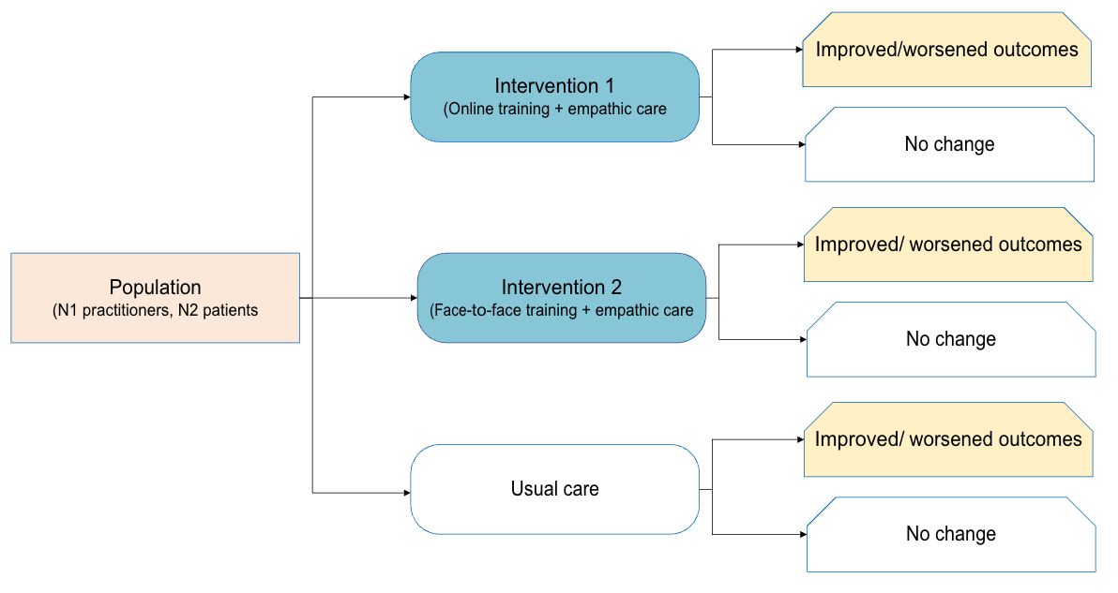
Fig 1. Decision tree model for the template model
An accompanying calculation diagram (Fig 2) illustrates how key model outputs including the number of patients and practitioners benefiting, costs per improved case, and cost offsets are derived from the decision-tree structure and underlying parameters.
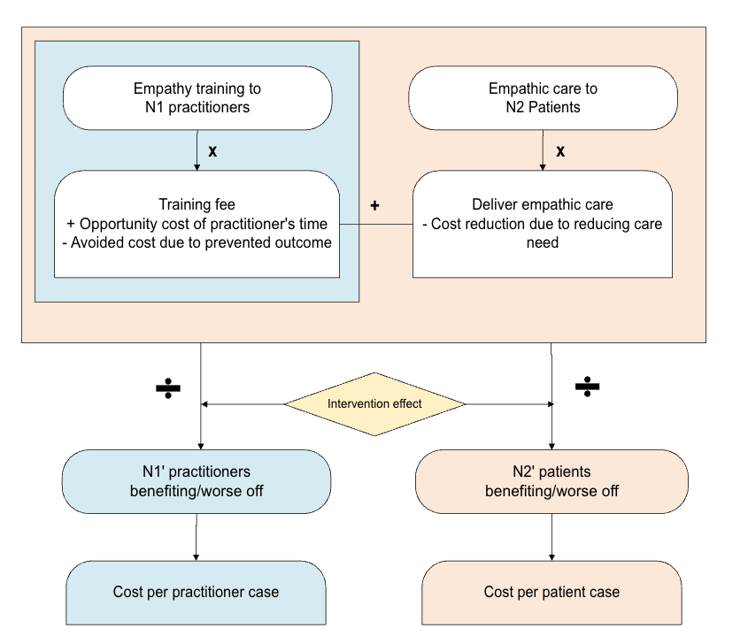
Fig 2. Calculation diagram of the template cost consequence analysis
In accordance with the NICE Reference Case, the economic perspective will be NHS and Personal Social Services (PSS). As there is no evidence of long-term benefits of empathic intervention, a one-year time horizon will be used in this study without discounting of costs or health benefits.

4.3 Sources of data for parameterisation – Targeted Literature Reviews
We will apply the following principle to all evidence sourcing:
- The information seeking processes underpinning the development of a model should be systematic and explicit.
- The processes of identifying and selecting evidence should be transparent.
- Information should include the reporting of search strategies, an audit of how individual sources of evidence were identified, information on alternative sources and an assessment of the impact of the limitations of the evidence base or of alternative sources on the outputs of the model.
- Given limited resources, decisions relating to the prioritisation of key information needs and judgments relating to when to stop searching should be transparent.
- In cases where both individual trials and the meta-analysis provide estimates of intervention effectiveness for a specific outcome, the value used in the model will be determined based on quality of available estimates. This choice will be tested in scenario analyses to account for variability and assess the robustness of the conclusions. This protocol was developed prior to the availability of results from the meta-analysis and therefore does not incorporate outcome-specific findings at this stage.
Empathy training costs are presented in Table 2. Lists of input parameters are presented in Table 3 and Table 4.
Table 2: Costs of the empathy training
Components (quantity) | Cost for face-to-face format (£) | Cost for online format (£)
Expert facilitator (1 expert) | 300 | 200
Training for facilitator | 10 | 10
Admin support (0.5 persons day) | 100 | 100
Resources (papers, pens,…) | 50 | 0
Lunch + refreshments | 1000 | 0
Total cost per session (100 people) | 1460 | 310
Total cost per person | 14.6 | 3.1

Table 3: Input parameters for the case study in primary care
Parameter | Base-case value | Standard error (SE) and distribution for PSA | Source/Note
Population
Number of GPs |  |  | NHS statistics
Number of patients visiting GPs annually |  |  | NHS statistics
% of patients with chronic pain |  |  | Literature
% of patients with anxiety |  |  | Literature
% of patients with depression |  |  | Literature
Intervention effect
SMD of pain |  |  | Ongoing meta-analysis
SMD of anxiety |  |  | Ongoing meta-analysis
SMD of depression |  |  | Ongoing meta-analysis
SMD of satisfaction |  |  | Ongoing meta-analysis
Proportion of burnout among GPs |  |  | Literature
Relative risk of burnout among GPs in the intervention vs control arms |  |  | Literature
Costs
Training fee – online per person (5 hours) | 3.1 |  | Inputs from the developer
Training fee - face-to-face per person (7 hours) | 14.6 |  | Inputs from the developer
Opportunity cost of GP time per hour |  |  | Literature
Cost associated with extended consultation duration |  |  | Literature
Cost offset associated with reduced pain |  |  | Literature
Cost offset associated with improved anxiety |  |  | Literature
Cost offset associated with improve depression |  |  | Literature
Cost offset per GP associated with reduced burnout |  |  | Literature
SE: standard error, PSA: probabilistic sensitivity analysis, SMD: standardized mean difference, GP: General practitioner

Table 4: Input parameters for the case study in secondary care
Parameter | Base-case value | Standard error (SE) and distribution for PSA | Source/Note
Population
Number of women diagnosed with recurrent miscarriage, defined as at least 3 pregnancy losses |  |  | Literature
Number of eligible patients under care of one nurse over 1 year |  |  | Literature
Intervention effect
Mean change in stress (pre vs post intervention) in the intervention arms |  |  | Chang 2021
Mean change in depression (pre vs post intervention) in the intervention arms |  |  | Chang 2021/ Meta-analysis
Mean change in stress (pre vs post intervention) in the control arm |  |  | Chang 2021/ Meta-analysis
Mean change in depression (pre vs post intervention) in the control arm |  |  | Chang 2021
SMD of satisfaction |  |  | Meta-analysis
Proportion of burnout among nurses |  |  | Literature
Relative risk of burnout among nurses in the intervention vs control arms |  |  | Literature
Costs
Training fee – online per person (5 hours) | 3.1 |  | Inputs from the developer
Training fee - face-to-face per person (7 hours) | 14.6 |  | Inputs from the developer
Opportunity cost of the nurse’s time (wage per hour) |  |  | Literature
Cost offset associated with reduced stress |  |  | Literature
Cost offset associated with reduced depression |  |  | Literature
Extra cost of delivering empathic care (in the intervention arm)  - Number of consultation sessions  - Duration of a consultation session  - Cost of a consultation session |  |  | Literature
Cost offset associated with reduced burnout in nurses |  |  | Literature
SE: standard error, PSA: probabilistic sensitivity analysis,

4.4 Sensitivity analysis
Sensitivity analysis will be used to explore uncertainty around the appropriate selection of data sources using both deterministic (e.g. threshold analysis) and probabilistic sensitivity analysis (PSA).

4.5 Subgroup analysis
The template model will allow subgroup analysis with up to 3 subgroups of the population according to the evidence from the related randomized trial.

4.6 Scenario analysis
To explore the impact of key structural assumptions on the cost-consequence results, we will conduct a predefined scenario analysis across all case studies. Two types of scenarios will be considered:
- Training effect duration scenario (applied to all case studies): The base case assumes that the effect of the training is sustained over a 12-month period, meaning that the provider receives training once and he/she is able to deliver empathic care effectively throughout 12 months. In the alternative scenario, the training effect is assumed to last for only 6 months, necessitating repeated training. These scenarios will influence the total cost of training and re-training.
- Consultation duration scenario (GP case study only): In the primary care case study, we will explore the potential increase/decrease in GP consultation time associated with delivering empathic care. The base case assumes a 2-minute increase per consultation. Scenario analyses will evaluate alternative assumptions of 0, 5, and 10-minute increase per consultation, reflecting uncertainty around how empathic care may affect consultation duration. These scenarios will influence the cost associated with the consultation.
- Effect size: we will apply either the estimate from the meta-analysis or that from the corresponding clinical trial, depending on which estimate was used in the base-case analysis.
These scenarios will be implemented as predefined options in the template model.

4.7 Model validation
The conceptual model, input parameters and model outputs will be validated by consulting clinical expert and the developer of the intervention.

4.8 Results
In general, the results of the template model will be presented as:
- Base-case analysis results: Disaggregated results such as number of patients benefiting/ worse off, number of clinicians benefiting/ worse off when the evidence is available. Costs of the intervention, opportunity cost, monetary benefit of the intervention (cost saved due to improved outcomes), total cost, cost per patient case, cost per provider case. As patient’s outcome improvements may occur in the same individuals, results are reported separately to avoid assumptions about overlap. These outcomes should not be interpreted as independent or additive.
- Sensitivity analysis results: Deterministic sensitivity analysis result will be illustrated using tornado diagrams. Where applicable, results of the PSA will be presented as a range or illustrated by histograms or cost-effectiveness planes.
- Subgroup analysis and scenario analysis results: will be presented in a table which is similar to the result of the base-case analysis.

Deliverables
We shall deliver one report with two sections or two reports for the efficacy and effectiveness part, and the economic part respectively.
The key deliverables for this proposed project will be as follows:

5.1 Economic model
- A fully working version of the model in R
- A technical report/set of instructions for running the model/conducting analyses
- A Shiny web-app to allow end-users with or without technical skills (e.g. researchers, developers, commissioners) to conduct scenario-specific analyses using a pre-populated library of input parameters.

5.2 Journal manuscripts
This will comprise a fully referenced journal manuscript of this cost consequence analysis (target journal to be agreed with Stoneygate Centre). These are likely to include the following sections:
- Abstract
- Introduction including aims and objectives
- Methods
- Results
- Discussion
- Conclusion
- Conflict of interest
- References
- Appendices

References
1. Howick J, Bennett-Weston A, Dudko M, Eva K. Uncovering the components of therapeutic empathy through thematic analysis of existing definitions. Patient Education and Counseling. 2025 Feb;131:108596.
2. Howick J, Moscrop A, Mebius A, Fanshawe TR, Lewith G, Bishop FL, et al. Effects of empathic and positive communication in healthcare consultations: a systematic review and meta-analysis. J R Soc Med. 2018 Jul;111(7):240–52.
3. Kahlon MK, Aksan NS, Aubrey R, Clark N, Cowley-Morillo M, DuBois C, et al. Glycemic control with layperson-delivered telephone calls vs usual care for patients with diabetes: a randomized clinical trial. JAMA netw. 2024 Dec;7(12):e2448809.
4. Keshtkar L, Madigan CD, Ward A, Ahmed S, Tanna V, Rahman I, et al. The Effect of Practitioner Empathy on Patient Satisfaction : A Systematic Review of Randomized Trials. Ann Intern Med. 2024 Feb;177(2):196–209.
5. Wilkinson H, Whittington R, Perry L, Eames C. Examining the relationship between burnout and empathy in healthcare professionals: A systematic review. Burnout Research. 2017 Sep 1;6:18–29.
6. Zhou H. Relationship between empathy and burnout as well as potential affecting and mediating factors from the perspective of clinical nurses: a systematic review. BMC Nurs. 2025 Jan 10;24:38.
7. Bennett-Weston A, Ward A, Burnett D, Hogg J, Knight R, Howick J. A Complex Intervention to Introduce a Culture of Empathy within Maternity Services: Addressing Individual, Team, and System-Level Factors [Internet]. Rochester, NY: Social Science Research Network; 2025 [cited 2025 May 26]. Available from: https://papers.ssrn.com/abstract=5185426
8. National Institute for Health and Care Excellence (NICE)NICE. The medical technologies evaluation programme [Internet]. NICE; 2017 [cited 2025 May 26]. Available from: https://www.nice.org.uk/process/pmg33/chapter/the-medical-technologies-evaluation-programme
9. Department of Health and Social Care. GOV.UK. 2023 [cited 2025 May 26]. Cost consequence analysis: health economic studies. Available from: https://www.gov.uk/guidance/cost-consequence-analysis-health-economic-studies
10. National Institute for Health and Care Excellence (NICE)NICE. A cost-consequence and cost-benefit analysis of interventions to improve social, emotional and mental wellbeing in schools: Social, Emotional and Mental Wellbeing in Primary and Secondary Education: Evidence review J [Internet]. London: National Institute for Health and Care Excellence (NICE); 2022 [cited 2025 May 26]. (NICE Evidence Reviews Collection). Available from: http://www.ncbi.nlm.nih.gov/books/NBK589476/
11. Chang SC, Kuo PL, Chen CH. Effectiveness of empathic caring on stress and depression for women with recurrent miscarriage: a randomized controlled trial. Complement Ther Clin Pract. 2021 May;43:101367.
12. Department of Health and Social Care. GOV.UK. 2022 [cited 2025 Jun 20]. Final report of the Ockenden review. Available from: https://www.gov.uk/government/publications/final-report-of-the-ockenden-review
13. Department of Health and Social Care. Reading the signals - Maternity and neonatal services in East Kent – the Report of the Independent Investigation. 2022 Oct;
14. Zhu Y, Liu L, Li D, Feng Z, Tang J. Impact of perioperative empathic care on postoperative psychological status in patients with cervical cancer. Altern Ther Health Med [Internet]. 2024 Jun 14;Epub ahead of print. Available from: https://ovidsp.ovid.com/ovidweb.cgi?T=JS&CSC=Y&NEWS=N&PAGE=fulltext&D=medp&AN=38870495

